Practical no 1
AIM:- Learn to navigate, upload, download, and manage files in the Hadoop Distributed File System (HDFS).

You are a Data Engineer at a retail company. You need to create an organized directory structure in HDFS, upload raw transaction logs from your local computer, verify the data, and prepare an output folder for analytics.

- Data
- Create a new directory in HDFS named /retail under your user home directory.
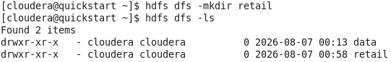
- Inside the /retail directory, create two sub-directories: raw_data and monthly_reports.List the contents of the /retail directory to verify both sub-directories exist.
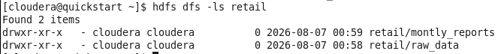
- Data Ingestion(uploading)
Create the file in local machine name sales_q1.csv and put data into it

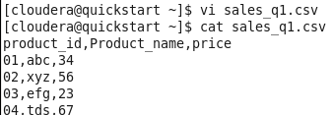
4.upload sales_q1.csv from local to hdfs directory /retail/raw_data/
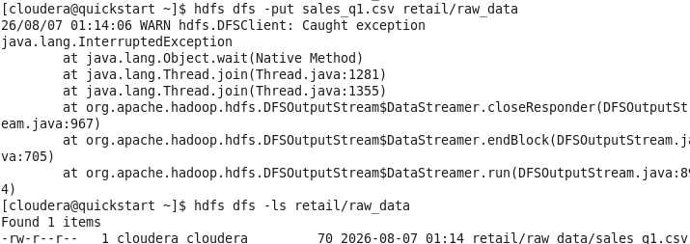
5.verify the file upload by listing the content of retail/raw_data. Check the file size

